Committed to delivering a safe environment
www.safegolf.org
for golf

Is something worrying you?
Do you need someone to talk to?
Speak to your club welfare officer
safeguardingcainhoe@outlook.com
07703 398896
Libby Moore

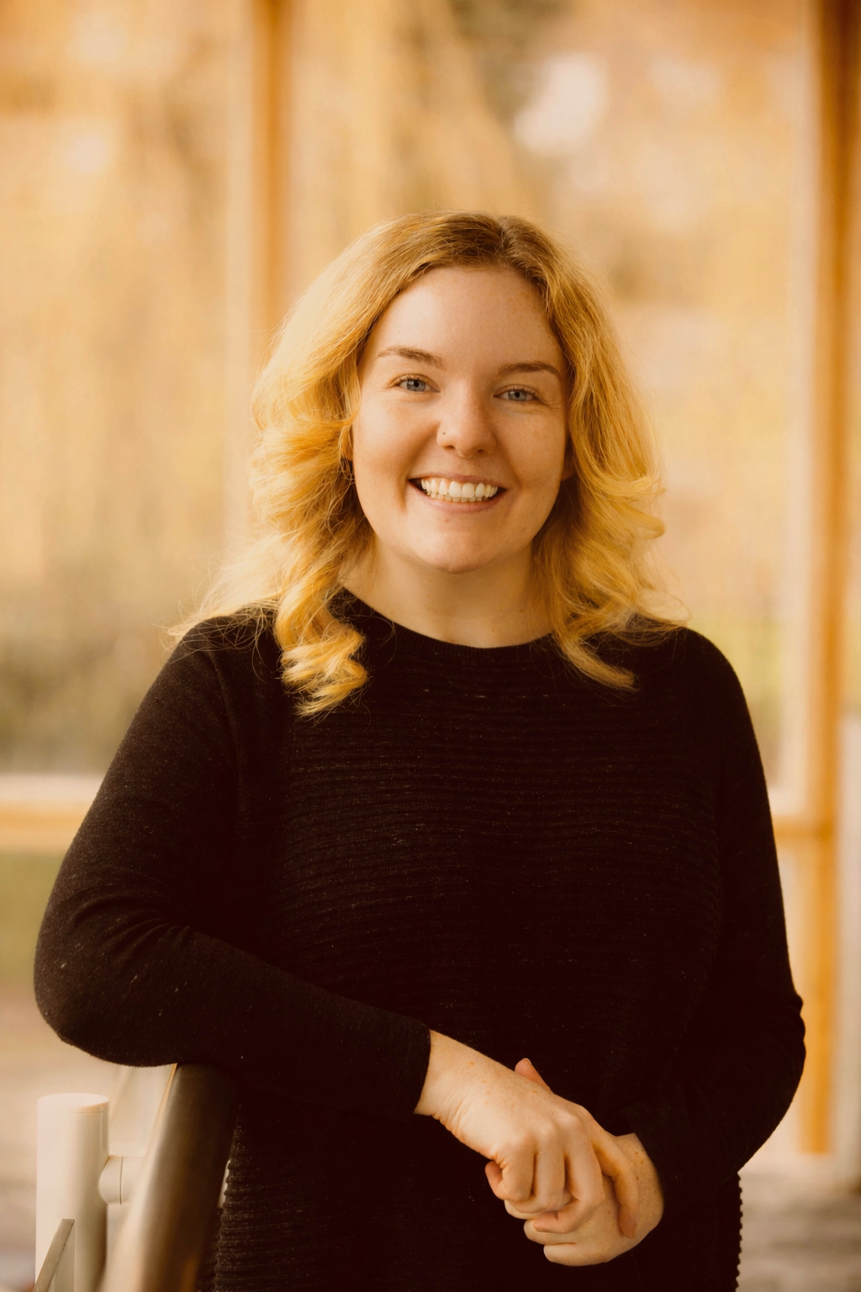

PHOTO

Click to add photo
Alternatively, you can speak to someone at
ChildLine 0800 1111
ABOUT ME

My stepson has been a member at Cainhoe Wood Golf Club since he was six, and through him I’ve seen how much the club does for its junior section.

I wanted to give something back by supporting the club and helping ensure it remains a safe, welcoming place for everyone

NSPCC 0808 800 5000
England Golf 01526 351851
Club
WELFARE
officer

